|  |
| --- |
| *Software Engineering-1*  *Software Requirements Specification*  *For*  *Web-Service to code project* |
| *Dr. Mohammad El Ramly*  *TA. Desoky Abdelqawy*  *Leader: Mariam Fouad Saeed*  *e-mail:*  *mariam-_-fouad@hotmail.com* |
| *Date:*  *November 8, 2014* |

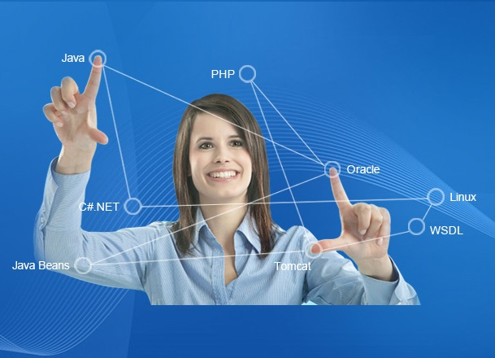

Contents

**Team 2**

**Document Purpose and Audience 2**

**Introduction 2**

**Software Purpose 2**

**Software Scope 2**

**Definitions, acronyms, and abbreviations 2**

**Requirements 3**

**Functional Requirements 3**

**Non Functional Requirements 3**

**System Models 4**

**Use Case Model 4**

**Use Case Tables 5**

**Ownership Report 6**

# Team

|  |  |  |  |
| --- | --- | --- | --- |
| ID | Name | Email | Mobile |
| 20120493 | Mariam Fouad Saeed | mariam-_-fouad@hotmail.com | 01115658976 |
| 20120195 | Salwa Ahmed Mahmoud | gaza_3ashekah@yahoo.com | 01158379344 |
| 20120446 | Huda Mohammad Abdel Raouf | huda.fci@gmail.com | 01286204342 |
| 20120456 | Yasmin Abdel Latif Mohammad | yasmeen.kloub@gmail.com | 01275511358 |

# Document Purpose and Audience

* **The purpose of this document is to present a detailed description of the Web-Service to Code Project. It will explain the purpose and features of the project, the interfaces of the project, what the project will do.**
* **This document is intended for developers of Web-Services.**

# Introduction

## Software Purpose

* **The purpose of this project is to help developers to integrate/consume a soap web service into his/her final application.**

## Software Scope

* **This Software system is created to help developers in their java application and generate classes’ methods from WSDL. This software will be a (Web-Service to Code) application; it should take the web-services WSDL link or source code as an input and generate the required classes/methods structure to encapsulate that web service.**
* **Furthermore, this software should provide a way for user to preview, alter/modify the generated source code files manually. The user of this software can easily use change the code and view it. As a first version, The Webservice2Code application should support .net soap web-services for java platform (including android). This software must have a simple interface so that any developer could use and benefit from.**

## Definitions, acronyms, and abbreviations

|  |  |
| --- | --- |
| Term | Definition |
| Web-service | a method of communication between two electronic devices over a [network](http://en.wikipedia.org/wiki/Computer_network). |
| WSDL | is an XML format for describing network services as a set of endpoints operating on messages containing either document-oriented or procedure-oriented information. |
| java | A high level programming language , its objective – oriented programming language |

# Requirements

## Functional Requirements

* **The software should take the WSDL as a link or code (from the device) from the user**
* **The software should show the list of function and method that want to be implemented and the user chose from them**
* **The software should transfer the chosen method into java code**
* **The software should allow the user to modify this code or other code in the device**
* **The software allow the user to save the code and the modify code in the device**

## Non Functional Requirements

|  |  |
| --- | --- |
|  | Details |
| Performance | * **Transforming the WSDL in less than 40 second** |
| Maintainability | * **The software return to normal function after break down in less than 20 second** |
| Usability | * **How to use guide and labels** |

# System Models

## Use Case Model

#### Use case: Submit the WSDL

**Diagram:**

Developer

Submit the WSDL

**Brief Description**

**The developer must input the WSDL link or source code to the software.**

**Initial Step-By-Step Description**

1. **Developer must open the software, he\she must click in the WSDL source button.**
2. **System view two option either the WSDL link or WSDL code.**
3. **The Developer chose the case he want.**
4. **The System must check it to valid the WSDL if developer must check the WSDL.**

#### Use case: Create the Code

**Diagram:**

Developer

Create Code

**Brief Description**

**The developer chose to create the source code and save it.**

**Initial Step-By-Step Description**

1. **User must click in the create code button.**
2. **Software must make sure that the developer Submit WSDL.**
3. **Developer must chose the place to save the source code file.**

#### Use case: Modify the Code

**Diagram:**

Developer

Modify the code

**Brief Description**

**The developer chose to modify the code either an old or a new code, and save it.**

**Initial Step-By-Step Description**

1. **User must click in the modify the code button.**
2. **Software ask the developer if he/she want this source code or an old code.**
3. **If developer choose an old code software view computer file to choose the old code source.**
4. **Software show the source code for the developer.**

## Use Case Tables

|  |  |  |
| --- | --- | --- |
| Use Case ID: | Usecase01 | |
| Use Case Name: | Submit the WSDL | |
| Actors: | developer | |
| Pre-conditions: | Chose the submit button | |
| Post-conditions: | Create the code | |
|  | User Action | System Action |
| 1- User chose to submit link or source code |  |
|  | 2- System open the file browser if chose source code |
| 3- user enter the link of the WSDL or chose the file he/she wants |  |
|  | 4- System verify the code and show list of methods name |
| 5- user chose the methods he/she wants |  |
| Exceptions: | If the source or link are not accepted form of WSDL the user should reenter it | |
| Includes: |  | |
| Notes and Issues: |  | |

|  |  |  |
| --- | --- | --- |
| Use Case ID: | Usecase02 | |
| Use Case Name: | Create the Code | |
| Actors: | developer | |
| Pre-conditions: | Chose the create button | |
| Post-conditions: |  | |
|  | User Action | System Action |
| 1- User chose to create the code |  |
|  | 2- System open new java file and generate the code in it |
|  | 3- System ask the user if he/she want to save the file |
| 4- user chose wither to save or not |  |
|  | 5- system show file browser of the device |
| 6- user chose the name and place of the file and click save |  |
|  | 7- system save the new file in the device |
| Exceptions: | Error in creating the file or accessing the specific file | |
| Includes: |  | |
| Notes and Issues: |  | |

|  |  |  |
| --- | --- | --- |
| Use Case ID: | Usecase03 | |
| Use Case Name: | Modify the Code | |
| Actors: | developer | |
| Pre-conditions: | Chose the modify button | |
| Post-conditions: |  | |
|  | User Action | System Action |
| 1- User chose to modify current open code or save in device |  |
|  | 2- System open the file browser if chose saved in device |
|  | 3- system open the specific file in new tab in the software |
| 4- user modify the code as he/she want |  |
|
| Exceptions: |  | |
| Includes: | Massage to save the code source or not after closing the tab | |
| Notes and Issues: |  | |

# 

# Ownership Report

|  |  |
| --- | --- |
| Item | Owners |
| Document purpose and audience ,Software purpose | yasmeen |
| Use case model table | Mariam |
| Software scope ,definition | huda |
| Function requirement and non-function requirement | *salwa* |